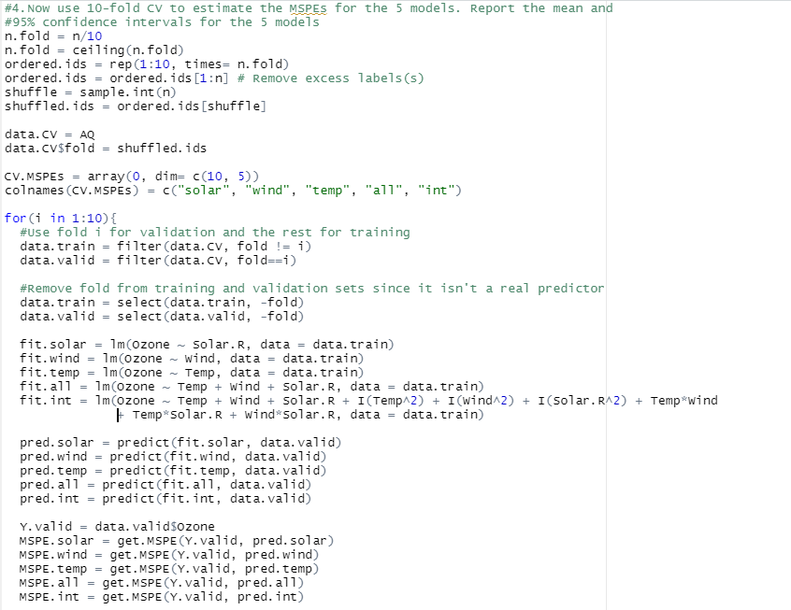

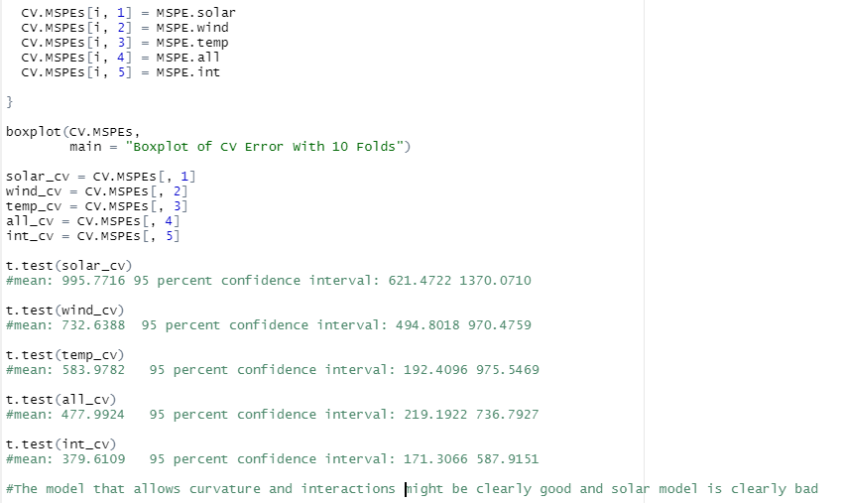

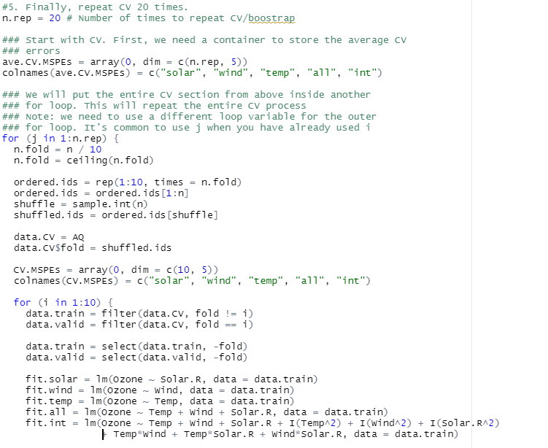

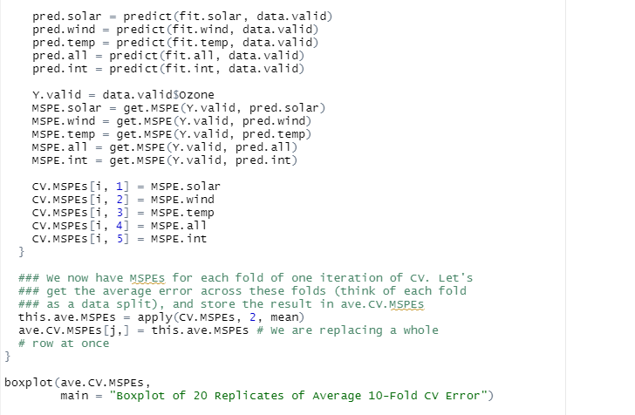

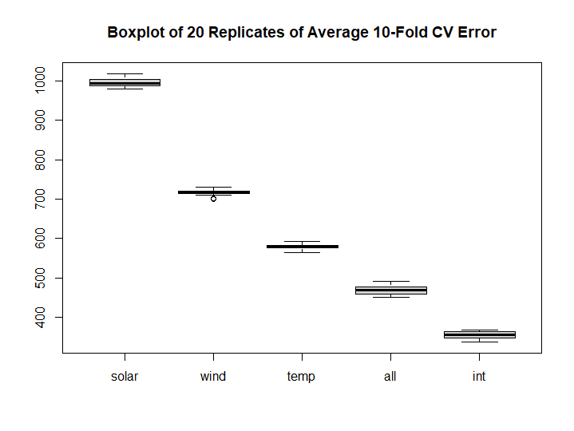

The boxplot is showing that clearly the model that allows curvature and interactions is better than others and the model that only using solar variable is worse.

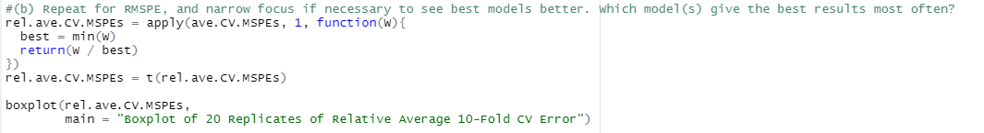

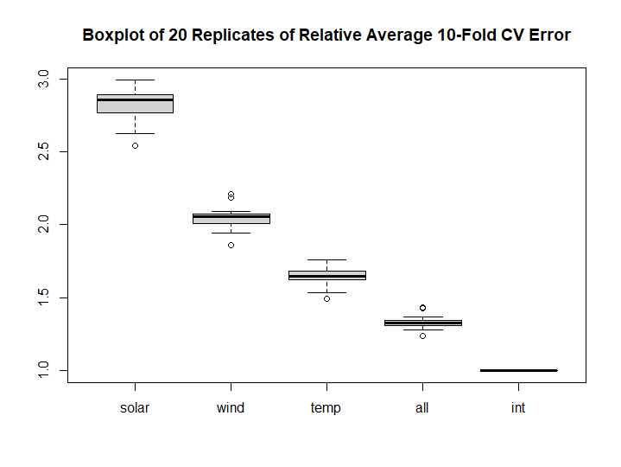

The model that allows curvature and interactions shows best result most often.

6. Based on what you’ve done, and considering practical concerns described in the preamble for the problem, which one model would you suggest using?

-> I would use the model that allows curvature and interactions.